STS-122: Booster Camera Launch Video 02.15.08
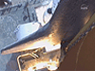

http://www.nasa.gov/multimedia/podcasting/STS122_srb.html

Views of Atlantis' launch from the solid rocket booster cameras (nature sound).

